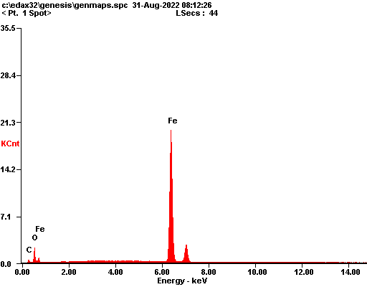

|  |  |  |
| --- | --- | --- |
| ***Element*** | ***Wt%*** | ***At%*** |
| ***CK*** | 07.23 | 22.29 |
| ***OK*** | 09.84 | 22.76 |
| ***FeK*** | 82.93 | 54.95 |
| ***Matrix*** | Correction | ZAF |

